Thoroughbred Racing History Association

**ANNUAL**

**REPORT**

**2023-24**

*Presented to the Annual General Meeting of the Thoroughbred Racing History Association, James McGill Library, August 21st, 2024.*

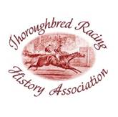

**PROUDLY SUPPORTED BY**

Your committee recently was asked to name the most interesting items in the Racing Museum as part of a review being conducted by the sector’s professional body, Museums & Galleries (Queensland), which offers guidance to operations like ours.

The answers to M&G’s request were illuminating, to say the least. Some of the nominations were the Julius totalisator which has worldwide recognition for its engineering ingenuity; Bill and Ev Stanley’s donated collection of memorabilia including a Cox Plate, Australian Cup and Doncaster and Stradbroke Handicap trophies; memorabilia associated with Bernborough’s remarkable career including his 1946 Doomben Cup trophy and his registration paper that became central to the controversy over his ownership; the display of memorabilia associated with Pam O’Neill and other pioneer women jockeys; memorabilia associated with Tulloch including the 1961 Brisbane Cup; and documents and photographs dating back to Queensland’s colonial times.

Other items were mentioned, and all served to underline the extraordinary collection of trophies, photographs, documents and artworks on display at the Museum at Eagle Farm and its associated Archive and the James McGill Library at Doomben. It has been a privilege for this Association to continue to assemble and take care of such a collection.

The review by Museums & Galleries has occupied much of the Association’s time in the past few months. It meant the preparation of a significant volume of paperwork, and our thanks to Karen Best for the painstaking work she put into this chore to present our activities to the examiners. Karen was ably assisted by Julie Anne Standfield and other committee members Steve Bermingham and Nev Hacker. The review included a field visit by two M&G officers to the Museum and Archive. Their report received this month has been largely complimentary, but it has identified some deficiencies in our operations and has suggested processes that need to be adopted. The Association needs to accept the report as a guide. However, to my way of thinking, some of the recommendations will be beyond our scope as a volunteer organisation with limited funds nor suitable for the management of what is a long-standing institution already fulfilling a function soundly with the generous and firm support of the Brisbane Racing Club. The committee has already moved to establish a collections policy as suggested, and it is our intention to address other issues in our coming operational year as best that we can.

A copy of the Field Visit Report is available from the Library on request.

A collection policy is necessary, given our limited storage facility and display areas. It will enable us to determine more easily what needs to be retained or disposed of, and we are determined to take a responsible attitude to the latter. Indeed, this past year we have supplied some of our duplicate books and magazines for use at the licensees’ holiday property on the Sunshine Coast.

The BRC is aware of our space limitations and the awkwardness of having our operations at separate venues, and has flagged expanding the Museum facility at Eagle Farm by converting much of the ground floor of the Tote Building for our purpose. The club has engaged an architectural firm specialising in museum presentation to make preliminary recommendations. However, we are aware that such a development is embryonic and in the long term can only be brought to fruition by external funding. Initial preparations for this project will determine some of our activities through the coming year such as a managed rationalisation of memorabilia and files.

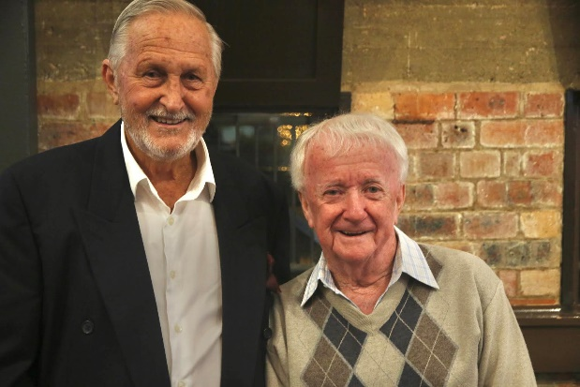The highlight of our past year was the presentation associated with the National Trust’s annual Heritage Festival in May**.** The function, Gunsynd the Legend, recalled the career of the Queensland horse that became Australia’s highest stakes-earner to his time and the most popular horse of his era. Compered by David Fowler and Bart Sinclair, the evening included interviews with his jockeys Kevin Langby and John Edmonds (pictured left) and a video of rarely-seen interviews by the late Wayne Wilson with trainer Tommy Smith and jockey Roy Higgins.

Sidelights to the presentation were noteworthy. Lucky Pippos, the brother of one of Gunsynd’s owners George and a successful owner in his own right, presented a magnificent framed photo of Gunsynd with Langby up to the former jockey. Retired jockey Kerry Smith, who had purchased Edmonds’ riding gear on his retirement, brought the white saddle that Edmonds used on Gunsynd in his races and presented it to the Museum. It will become a centrepiece for a themed display about Gunsynd that is in the planning. Goondiwindi journalist and historian Phil Percival presented to the Library copies of his well researched book “Gunsynd – The Goondiwindi Grey”, and the audience of 200 included guests who had travelled from Goondiwindi for the function.

We were chuffed to hear David Fowler remark that the annual event, which was in its 10th year, had become so successful that it was now part of the off-track activities associated with the BRC’s Stradbroke Season.

In the past year we have been offered and have gratefully accepted memorabilia and literature that reflects the history of racing in Queensland which is the core of our mission.

Only last week we were donated a race book for a meeting conducted by the Darling Downs Jockey Club in 1866. Initial research indicates the Jockey Club had been founded in 1862 and the 1866 meeting was held at Drayton near Toowoomba. The race book (right) is in delicate condition and requires careful handling but will be prepared for display. The Museum already has on display the 1862 Drayton Cup trophy, believed to be one of the oldest pieces of sports memorabilia in Queensland.

Recently we were gifted the private library of books from the estate of Fred Manahan, long-time Brisbane’s eminent racing veterinary surgeon and a foundation committee member of this Association and a true aficionado of racing.

Through the meticulous work of committee member Ross Stanley the Association has taken into its care and storage the negatives from the commercial operations of Three Way Photos that covered provincial and country race meetings for many years in south-east Queensland.

The Association purchased a showfront cabinet for a women jockeys’ display featuring memorabilia donated by Hall of Fame member Pam O’Neill who worked so hard for women to be licensed as jockeys. The display also includes reflections on two other Queensland women, Eva Draper and Wilhemina Smith, who managed to find a way around the official rules to ride in races in their times. Draper (right) rode on country tracks and on unregistered courses in Brisbane early last century. This display is positioned in a public area on the first floor of the Doomben grandstand and drew special mention in the Museum & Galleries review.

Steve Bermingham continued to finesse a huge volume of racing data that can be accessed through two interactive kiosks, one located in the Tote Building at Eagle Farm and the other here at Doomben. Steve is our website manager, and he and Ross Stanley have expanded the data on the site significantly. Steve reports that the website attracts daily an average of 128 visitors viewing 146 pages. We have noticed an increased number of inquiries about our activities being messaged to us through the revamped website.

The two interactive kiosks and display cabinet as well as extra book shelves for the Library have been purchased with funds provided through the generosity of the Bernborough Club, a long-time practical supporter of our activities. A grant from our local MLA Tim Nicholls enabled the purchase of office equipment.

The Association continues to host formal tours of the Museum and Archive. There has been an increased inquiry into this activity recently from community groups such as Probus clubs. On the other hand, the Association was invited to provide a guest speaker for two Probus club functions, which enabled us to promote the Museum and Library. There were two visits which had particular purposes. One was a visit by industry trainees from Korea that Chris Morrison hosted. Recently, Ross Stanley and Chris hosted an interactive visit to our Doomben facility for 18 students from the Hendra Primary School as part of the school’s 160th anniversary celebrations.

For the 2023-24 year your committee comprised Julie Anne Standfield (secretary), Bruce Halligan (treasurer), Chris Morrison (assistant secretary), Peter Howard (president), Karen Best, Ray Moriarty who resigned in July, Paul O’Grady, Paula Burnett, Nev Hacker, Ross Stanley and Michael Connolly. As president, I thank all the committee for their work and support for our mission through the year.

A special thank you goes to Bruce Halligan, our treasurer, who has been meticulous with recording and controlling our finances and when needed has taken on the task of liaising with the Office of Fair Trading.

Our thanks to the BRC executive and staff, specially chairman Neville Bell and fellow director Richard Morrison and our ever-supportive liaison Bart Sinclair for their continued assistance for our activities.

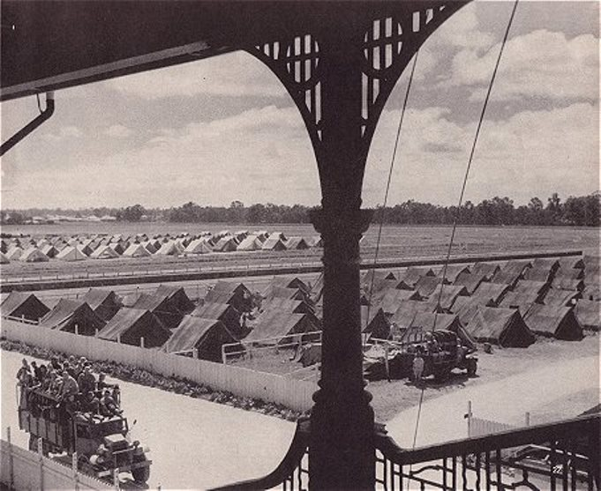 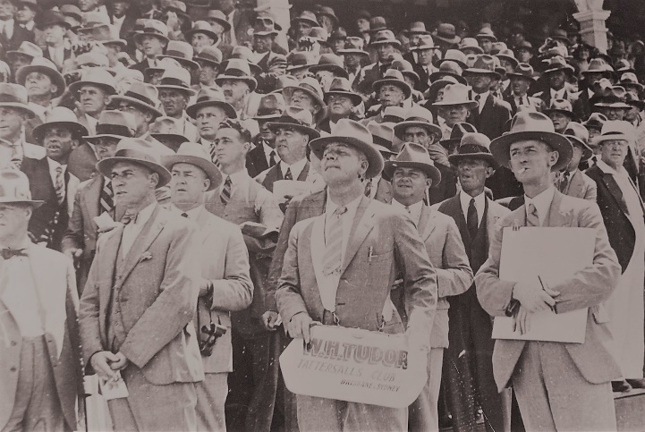

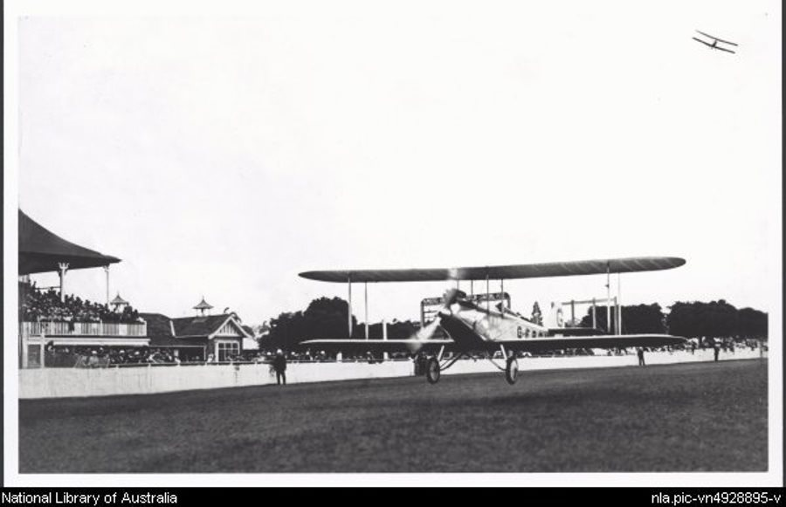 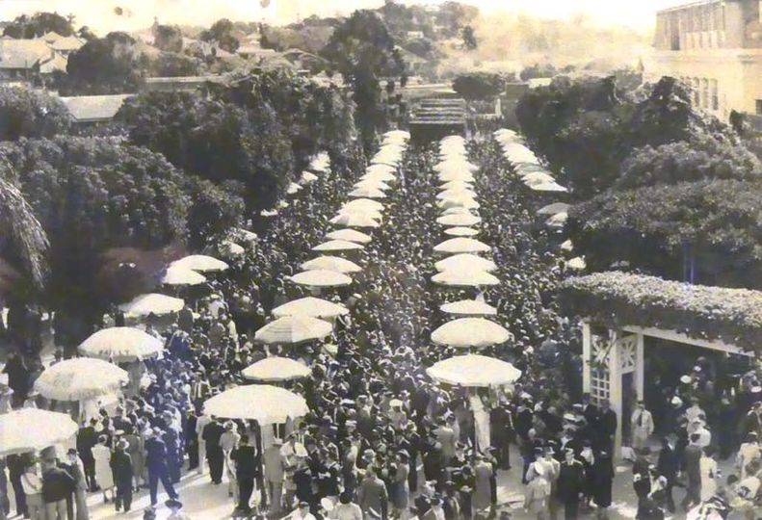

**FROM our files . . . (Clockwise from top left). 1. Eagle Farm was converted to a military staging camp between 1941 and 1945. 2. Punters (and a bookmaker and his clerk) at Albion Park 1930s. The bookmaker was there to take bets in the running. 3. The main Paddock betting ring, Eagle Farm, May 1946, when racing resumed after World War II. 4. Pioneer aviator Bert Hinkler landing at Eagle Farm 1928.**