Thoroughbred
Racing
History
Association

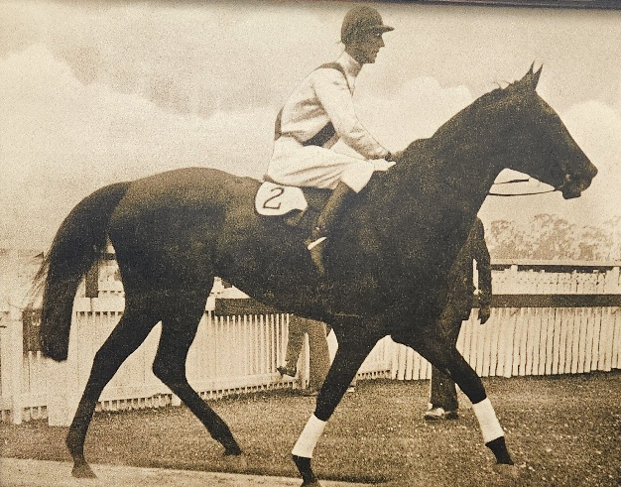

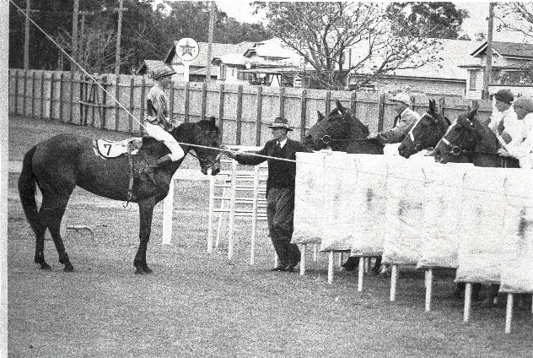

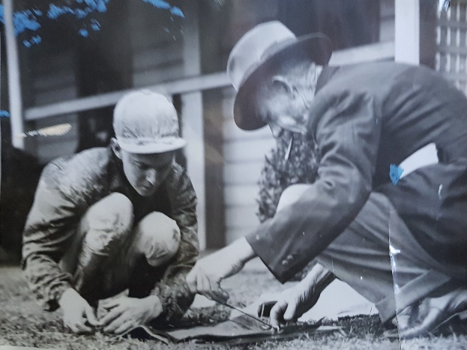

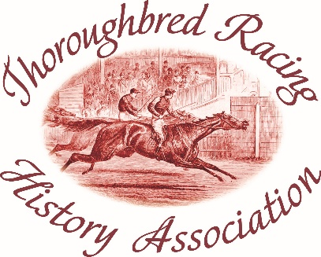

ANNUAL
REPORT 2026

Presented at
The Archive
Doomben Racecourse
September 16, 2026

So much has happened in the past year it is difficult to identify the most important. Therefore, let’s outline the Association’s advances and accomplishments with a series of dot points.

# As Bruce Halligan will point out in his treasurer’s report, our finances grew strongly through the year mostly from the Brisbane Racing Club directing funding our way after the 160-year anniversary of racing at Eagle Farm and then the BRC electing the Association as the beneficial charity from its Ladbrokes Stradbroke Calcutta, plus the Bernborough Club generously including the Association again among its disbursements to charities at the end of the financial year.

The Association thanks these benefactors for their assistance which has enabled us to continue to improve the Racing Museum and the Archive & James McGill Library as a valuable heritage centre for Queensland racing’s rich history. Their contributions enable us to implement best practice and plan further improvements with confidence.

# Central to our best practice has been the engagement of an credentialled archivist, who has enabled the Archive and Library to develop a professional approach to our activities and establish a more presentable shopfront for visitors. The Association thanks our archivist Jeni Bush and work experience student Laura Scott for sharing their expertise and guidance and their contributions to our efforts.

Improvements developed under their watch would not have been possible without the contribution of your committee members and other supporters through their volunteer work. Their work such as deframing pictures has been immense, yet they willingly accept ongoing chores that require attention.

The deframing of selected pictures has been a space saver in the storage rooms. This enabled the Association to accept responsibility for the safe keeping of some 48 pictures, works of art and other memorabilia that had been used as décor through the John Power Grandstand and its function rooms.

# Karen Best has driven a program of rationalisation. She has identified and separated duplicate volumes of various publications, isolated unwanted books and magazines and developed a sealed storage system for the volumes of registration papers from 40 years of records that had been archived by the Queensland Turf Club. This has resulted in making much needed space available on the bookshelves to provide easy access for an extensive research collection built largely around Queensland Racing Calendars and Turf Registers, QTC annual reports and committee meeting minutes all of which date from the 1880s.

Hardly a week goes by without committee members having to use these volumes to answer questions, mostly from descendants of licensees seeking information about their forebears’ involvement in racing.

# The Museum at Eagle Farm remained closed from October to April while the ground floor of the Old Tote Building was converted to office space for the BRC. Included in the improvements was an eye-catching inbuilt display cabinet for Museum memorabilia as a feature of the office reception area. We selected some of our most valuable trophies and mementos for display, including the 1889 Brisbane Cup, the 1862 Drayton Cup (believed to be one of the oldest sporting trophies in Queensland), Bernborough’s 1946 Doomben Cup and racebooks from his “lost years” in Toowoomba and the silks carried by the Queensland mare Lady Linden when she won the 1931 Stradbroke Handicap and 1932 VRC Newmarket Handicap.

A new feature is a video monitor, and the first slide show presentation was a video prepared by Terri Halcrow showing 50 cartoons of Racing Terms Illustrated taken from the Racing Calendars of the 1970s.

# Again, we hosted a function in May as part of the National Heritage Week activities. This year we highlighted the career of Vo Rogue, the champion of the 1980s, with his legendary jockey Cyril Small and Debbie Osborne, who worked closely with the late Vic Rail and rode the horse in his trackwork providing insights into the Vo Rogue’s career. We again are indebted to David Fowler and Bart Sinclair for their presentation of the evening.

# Our immediate challenge is to promote the Museum at Eagle Farm and the heritage unit at Doomben as tour destinations. Visitor numbers have not recovered since the Covid disruption, and implementation of a marketing strategy should be an early agenda item for the incoming committee.

Your committee for the past year has been Julie Anne Standfield (secretary), Bruce Halligan (treasurer), Steve Bermingham, Karen Best, Christine Morrison (ex-officio, tours coordinator), Bruce Carroll, Diane Gant, Nev Hacker, Jim McGill, Ray Moriarty, Greg Williams, Terri Halcrow and Daniel Hamilton.

Finally, we thank the Brisbane Racing Club for its generous support and in particular the club chairman Richard Morrison and director Jennifer Creaton, chair of the BRC Foundation, and community and engagement manager Deb Isaak who take a keen interest in our work.

Peter Howard
President Thoroughbred Racing History Association.

PROUDLY SUPPORTED BY





